## Environment Configuration

Environment variables are those which provide a list of web services to your web application. All the environment variables are declared in the **.env** file which includes the parameters required for initializing the configuration.

Laravel includes a middleware that verifies whether the user of the application is authenticated or not. If the user is authenticated, it redirects to the home page otherwise, if not, it redirects to the login page.

## Retrieving Input

The input values can be easily retrieved in Laravel. No matter what method was used **get** or **post**, the Laravel method will retrieve input values for both the methods the same way. There are two ways we can retrieve the input values.

* Using the input() method
* Using the properties of Request instance

--- Using the input() method

-- Using the properties of Request instance

### Using the input() method

The input() method takes one argument, the name of the field in form. For example, if the form contains username field then we can access it by the following way.

$name = $request->input('username');

### Using the properties of Request instance

Like the **input()** method, we can get the username property directly from the request instance.

$request->username

What is facade in laravel?

A **Laravel facade** is a class which provides a static-like interface to services inside the container. These **facades**, according to the documentation, serve as a proxy for accessing the underlying implementation of the container's services

# Laravel - Forms

Laravel provides various in built tags to handle HTML forms easily and securely. All the major elements of HTML are generated using Laravel. To support this, we need to add HTML package to Laravel using composer.

composer require illuminate/html

**config/app.php.**

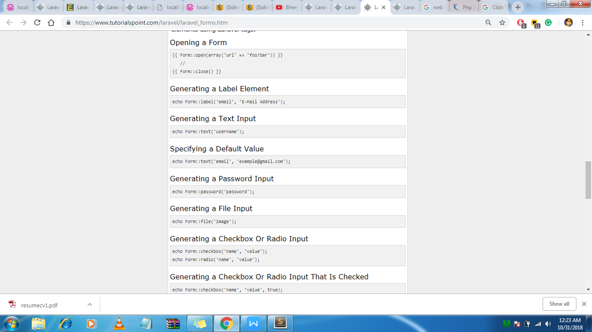

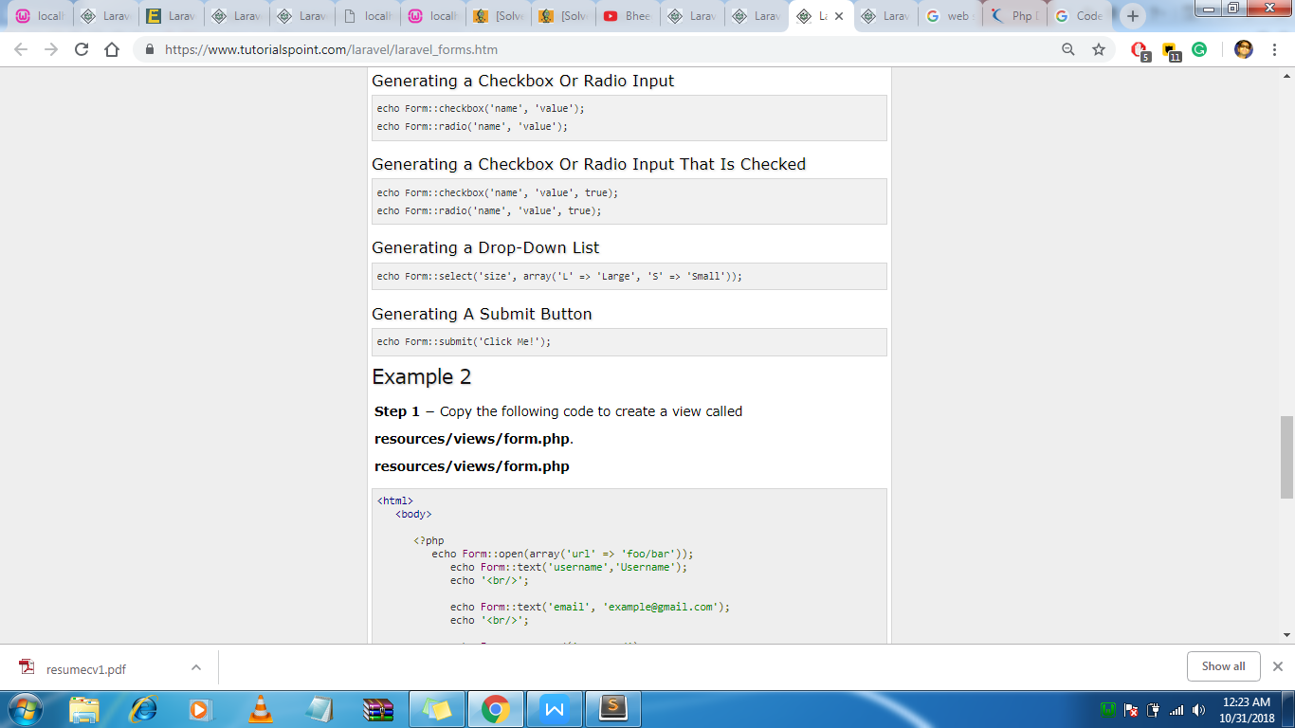

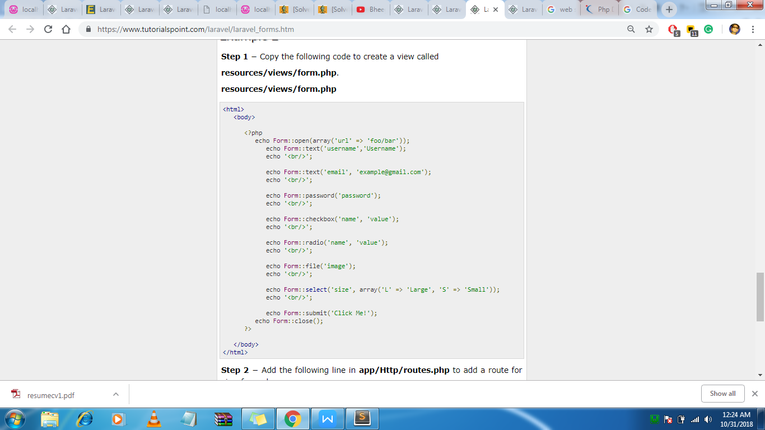

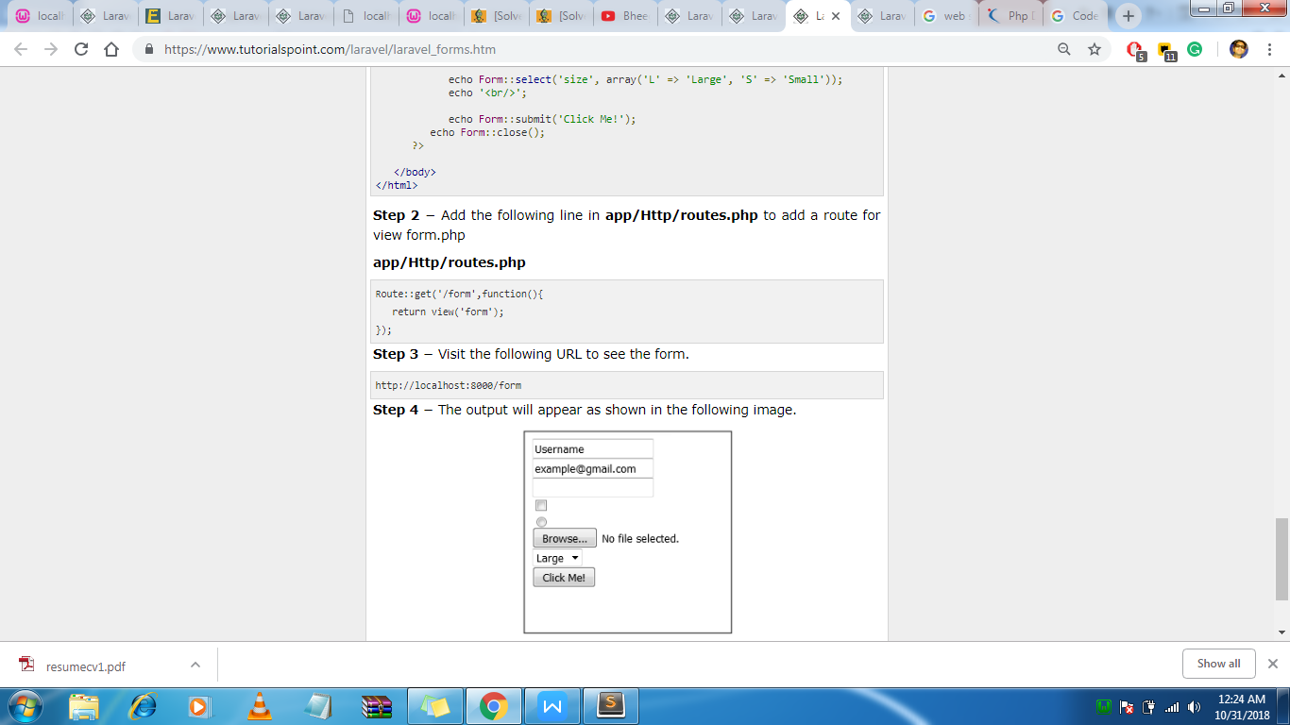

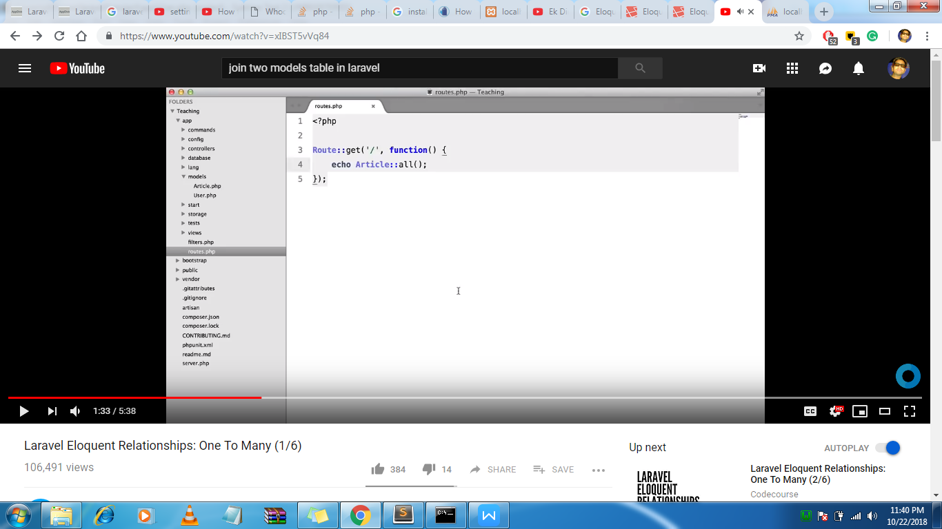

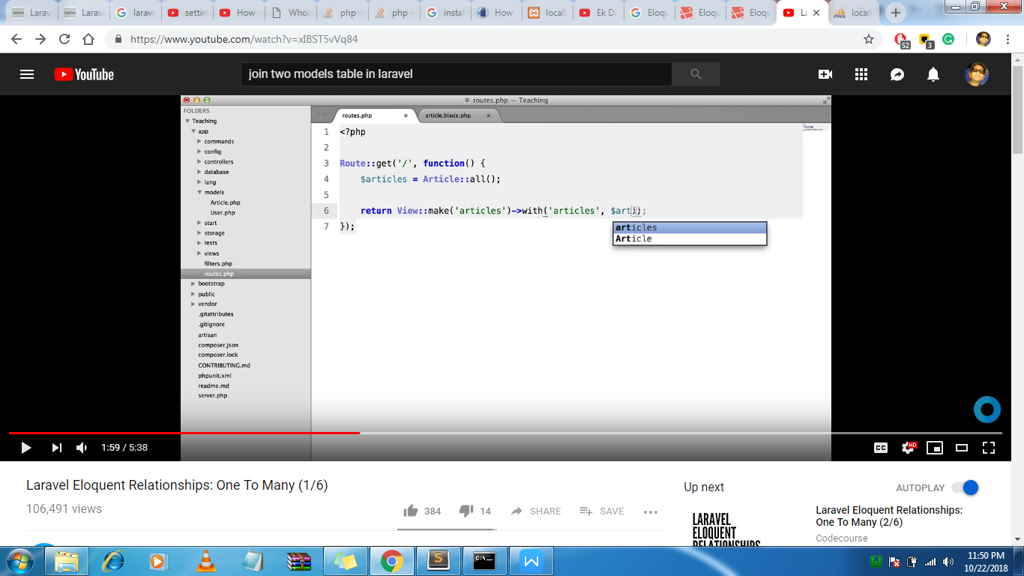

Belongs to(here in our case article belongs which user)

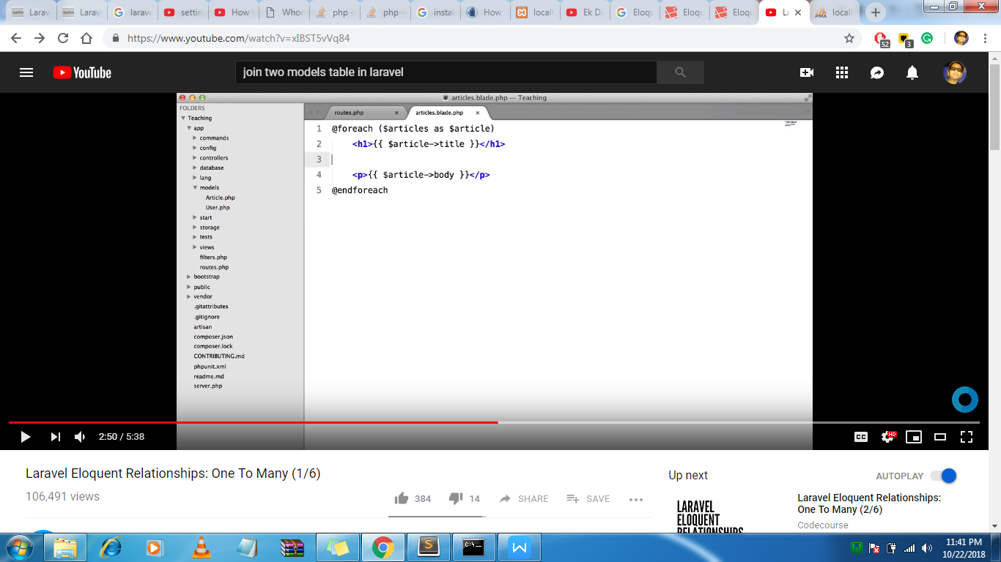

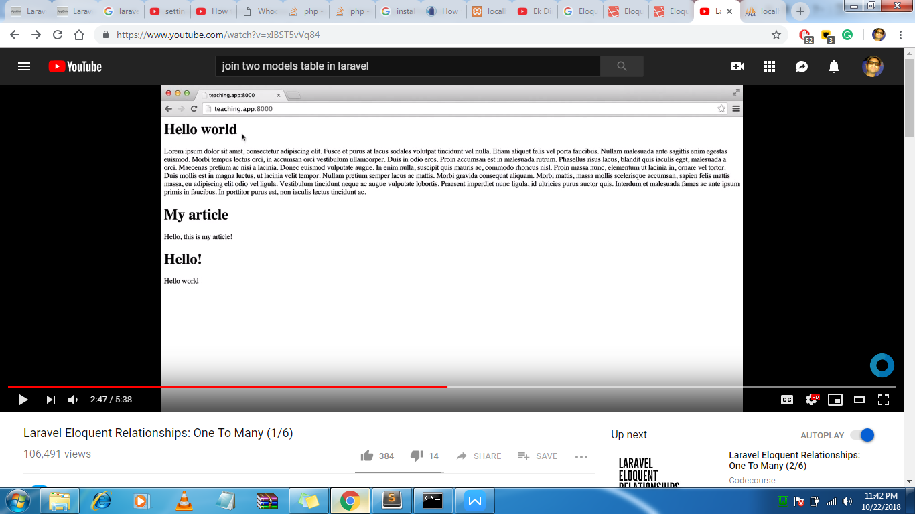

///

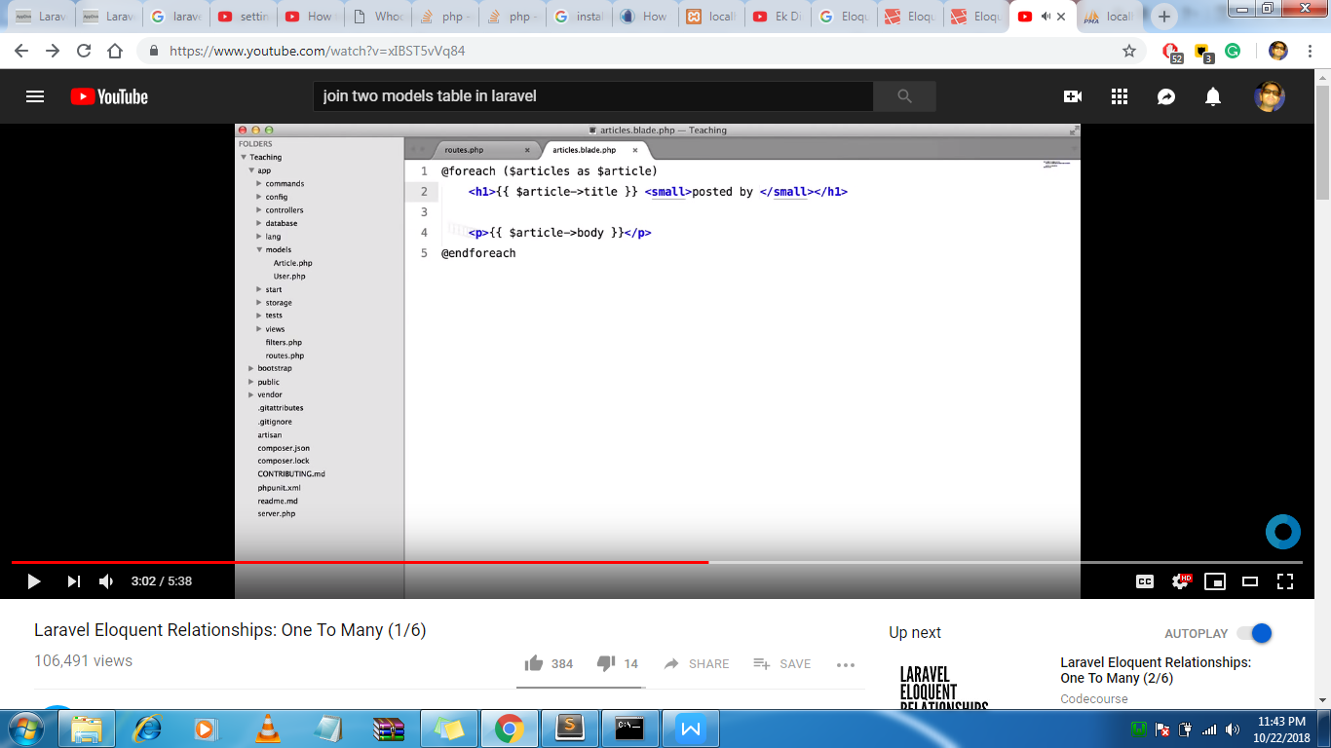

Now we want to add posted by for that we will use the model of user

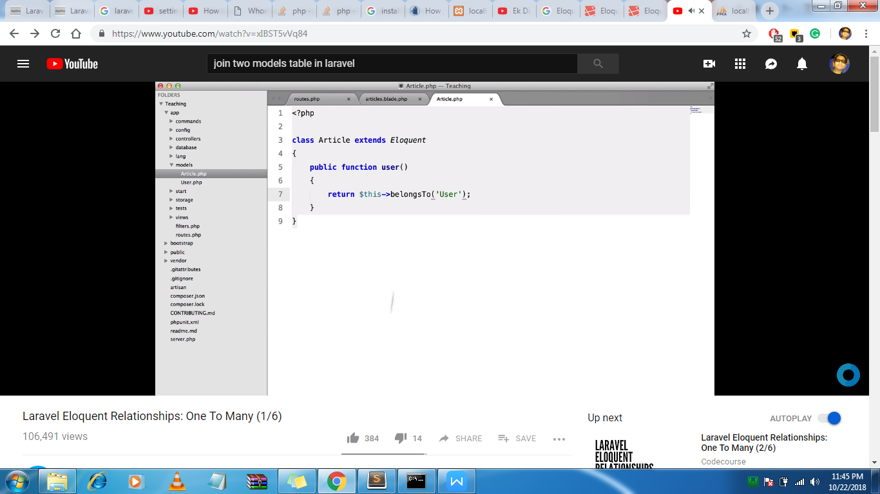

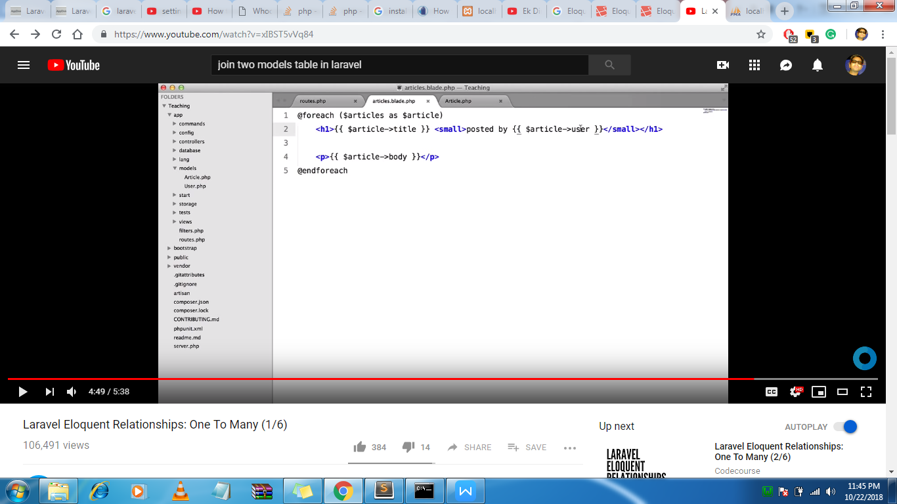

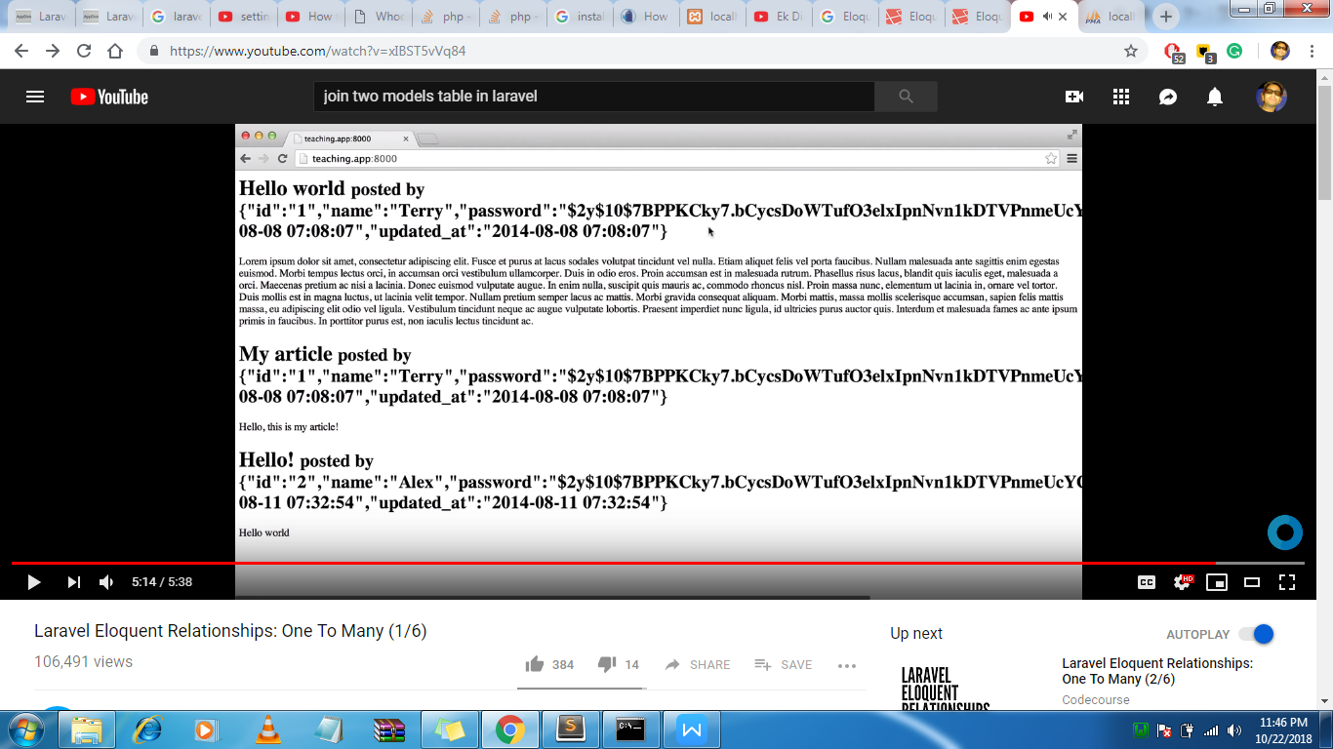

Or

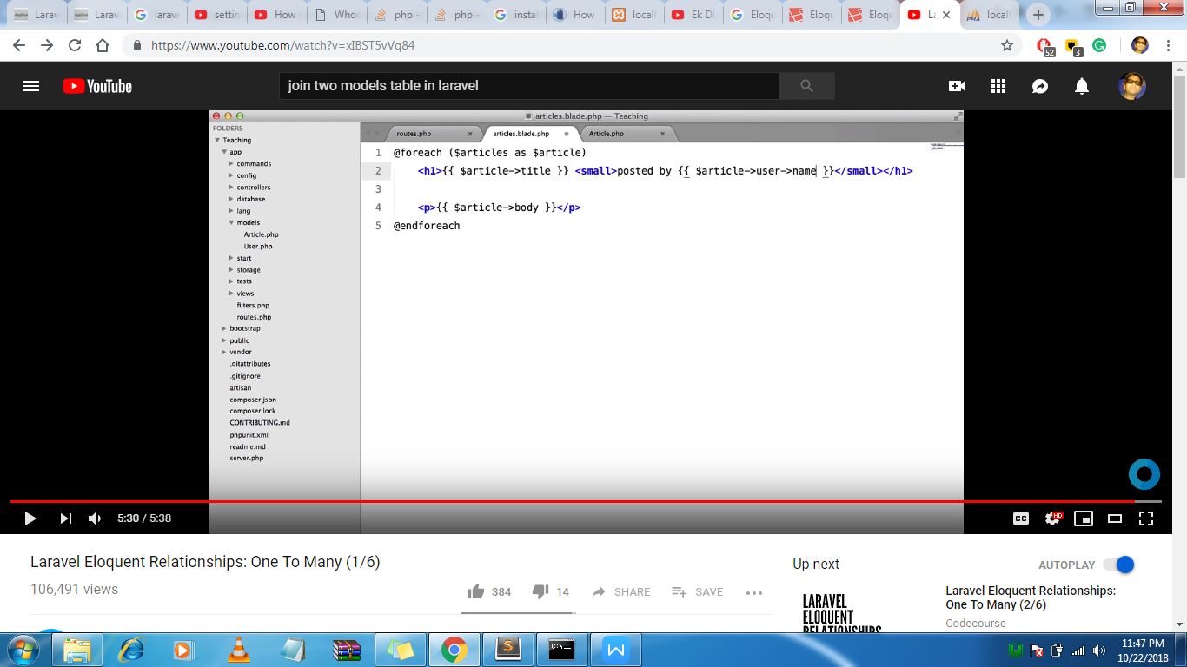

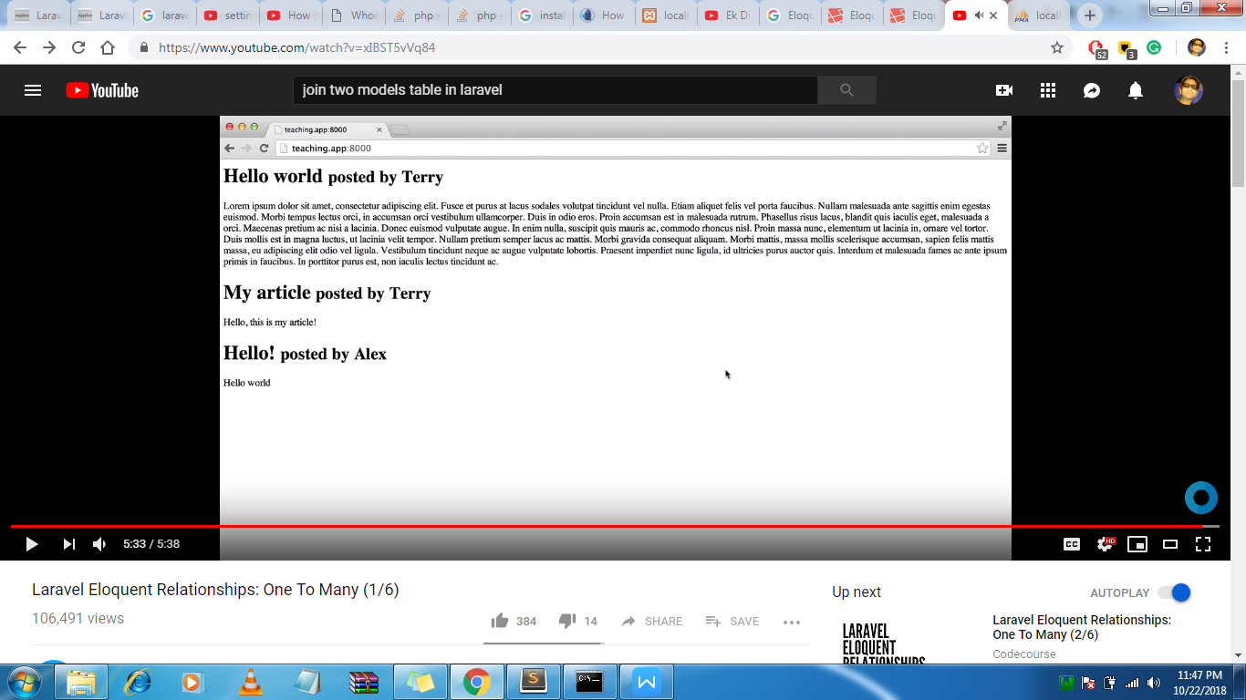

Hasmany

If we provide username in the model then it will load from the database .

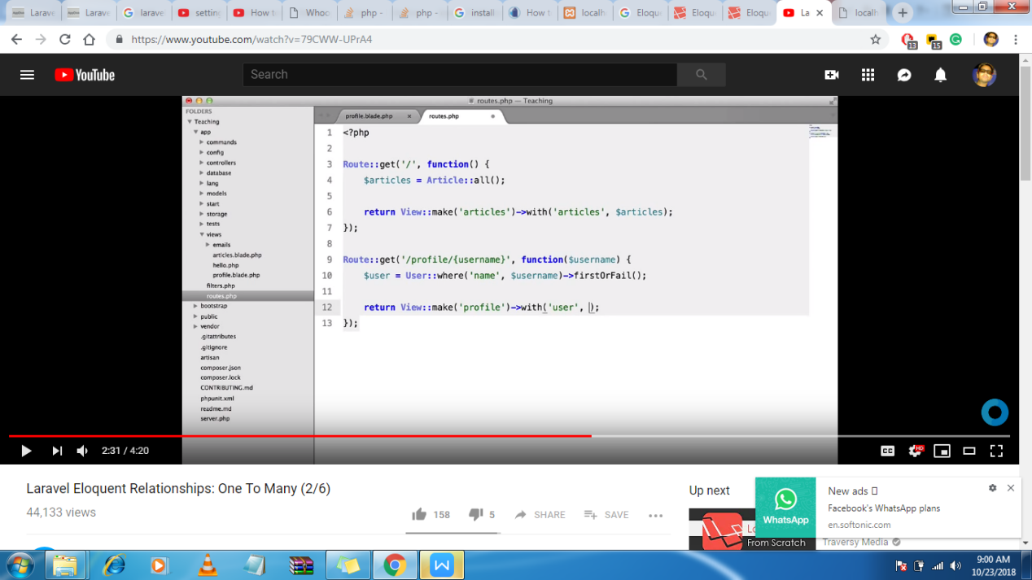

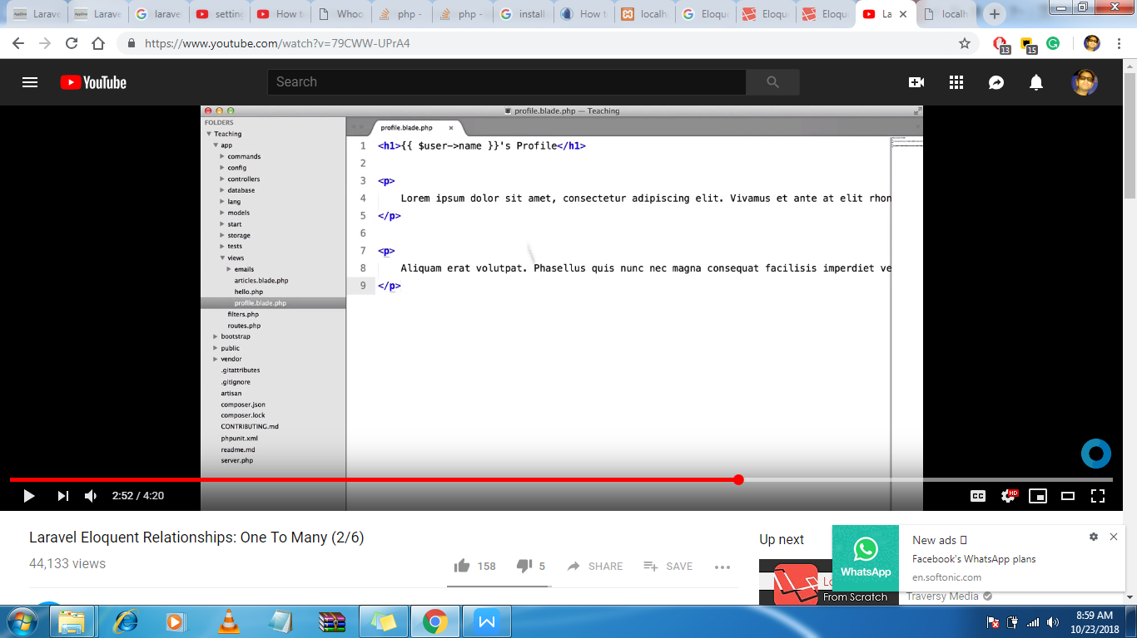

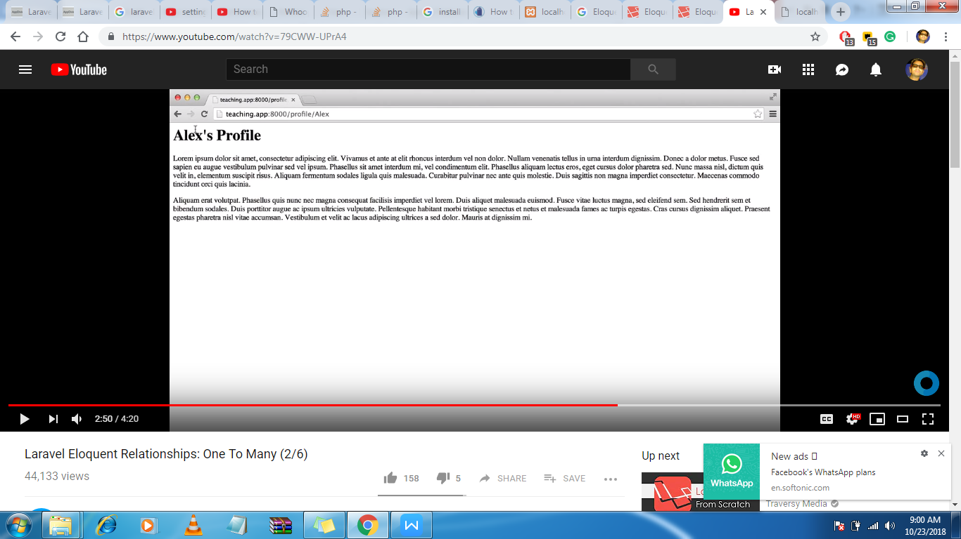

//

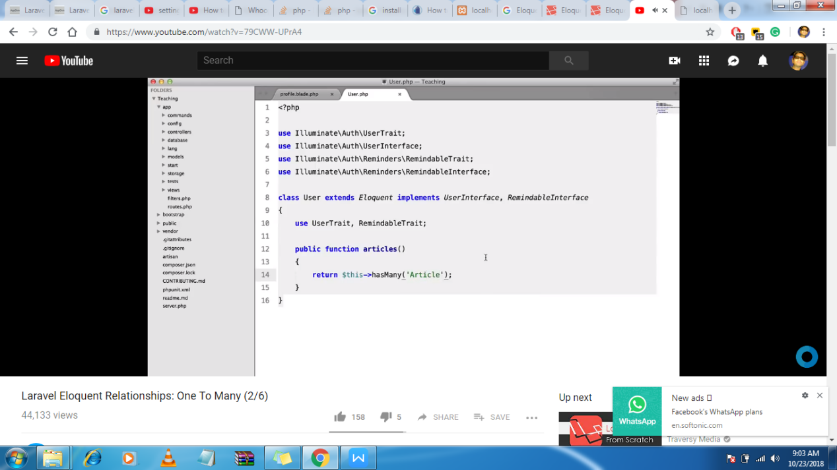

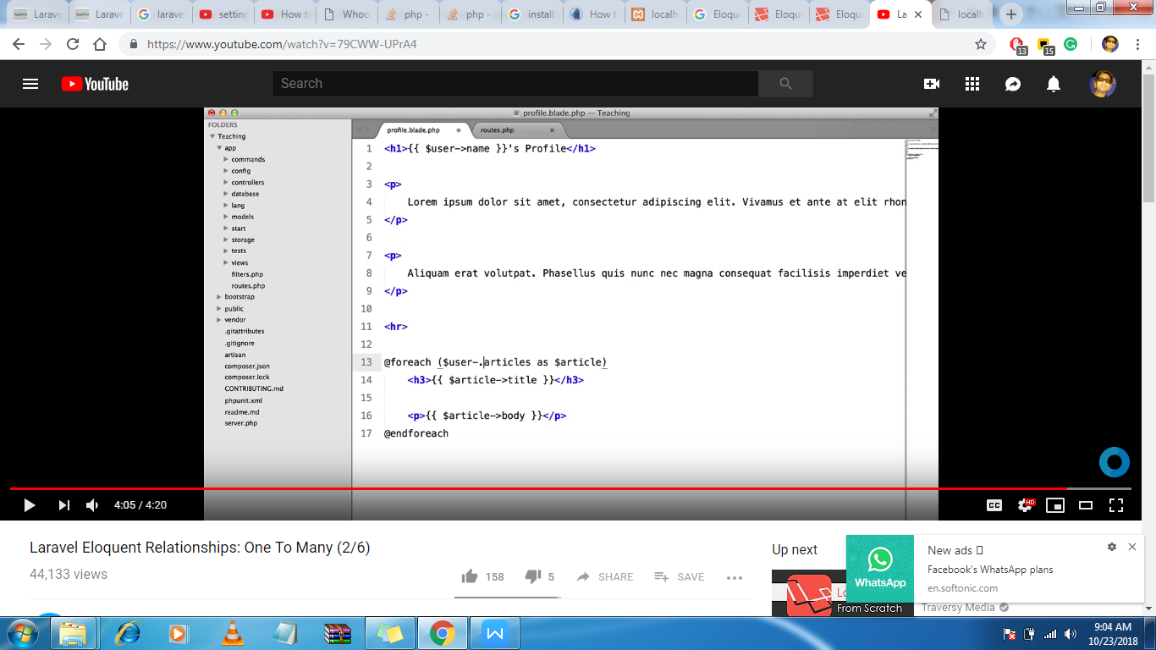

/////////////////

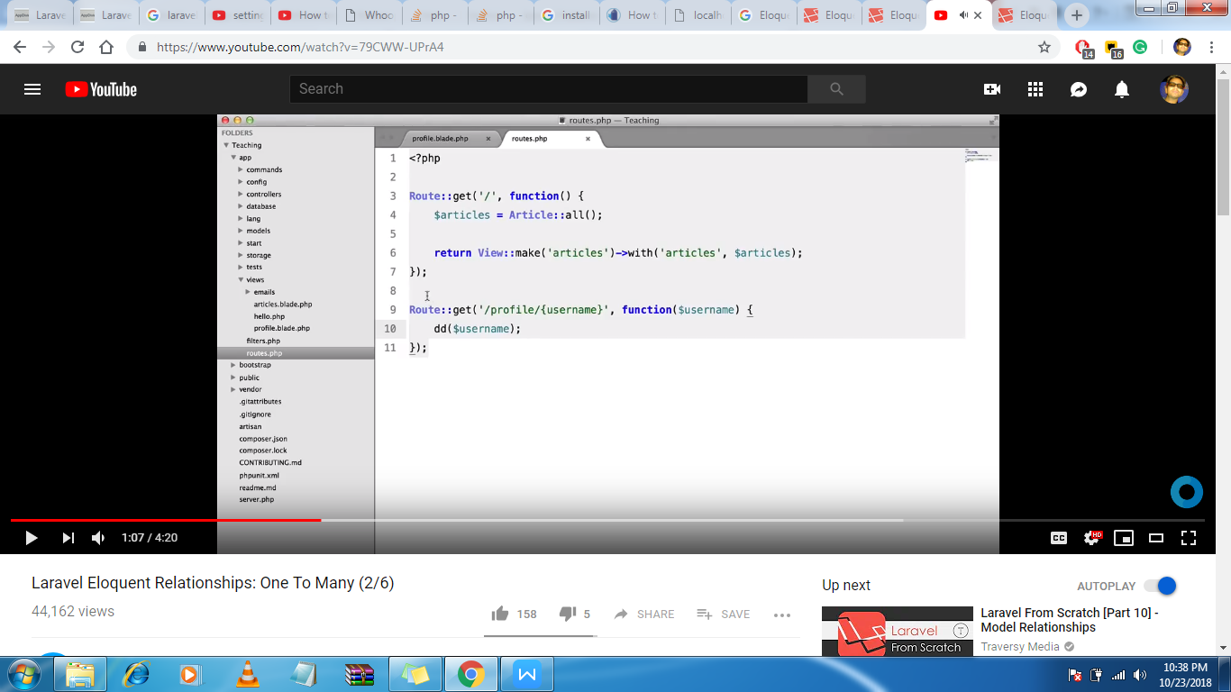

Now we want username whatever is provided in the URL

For that we will load the model and get the username and then load the view

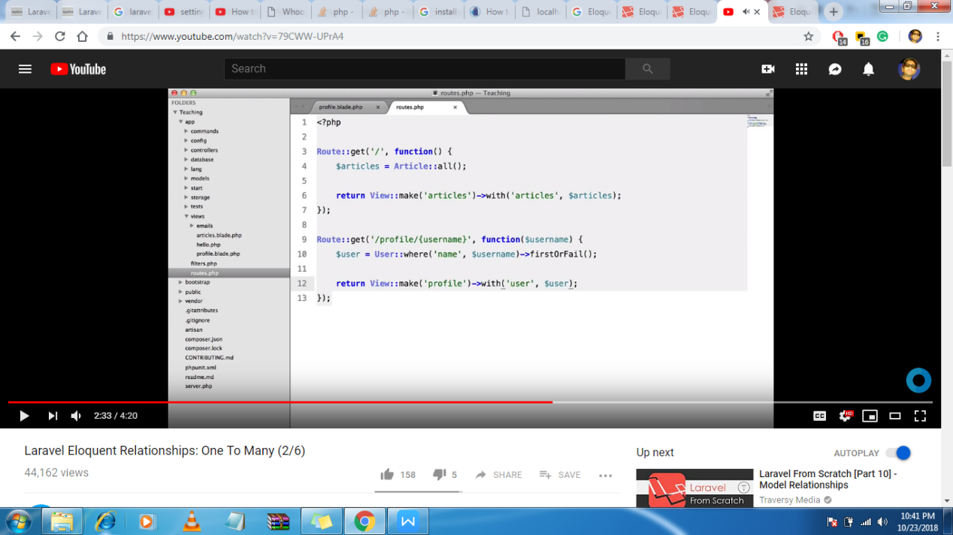

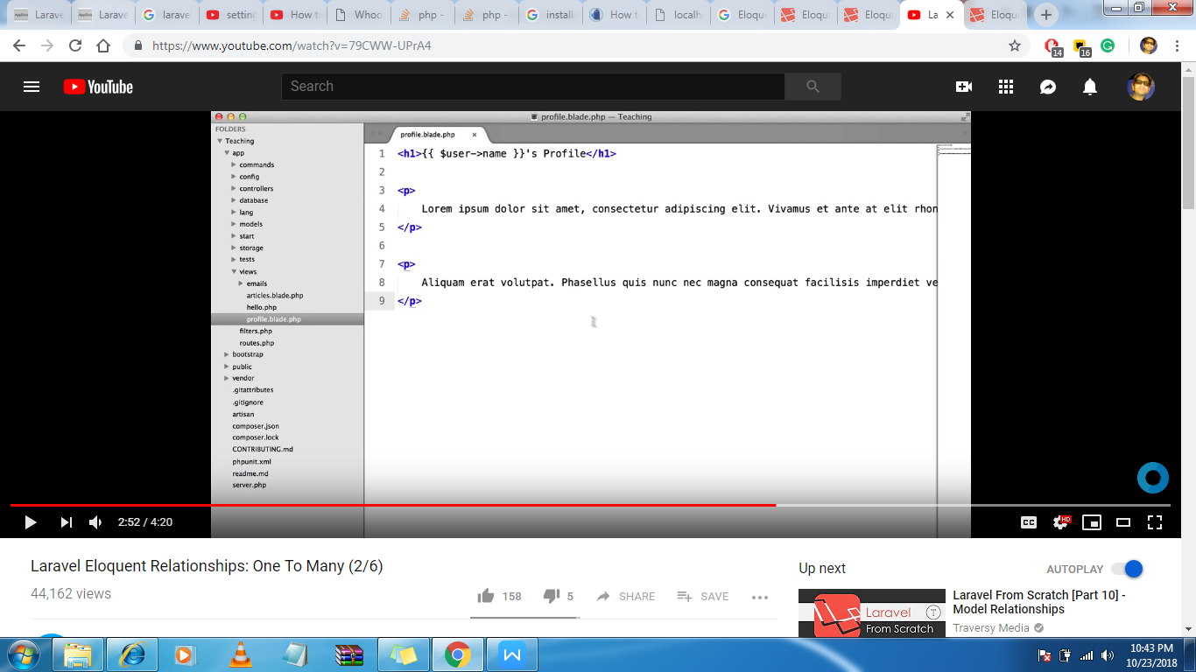

Now we also load the article

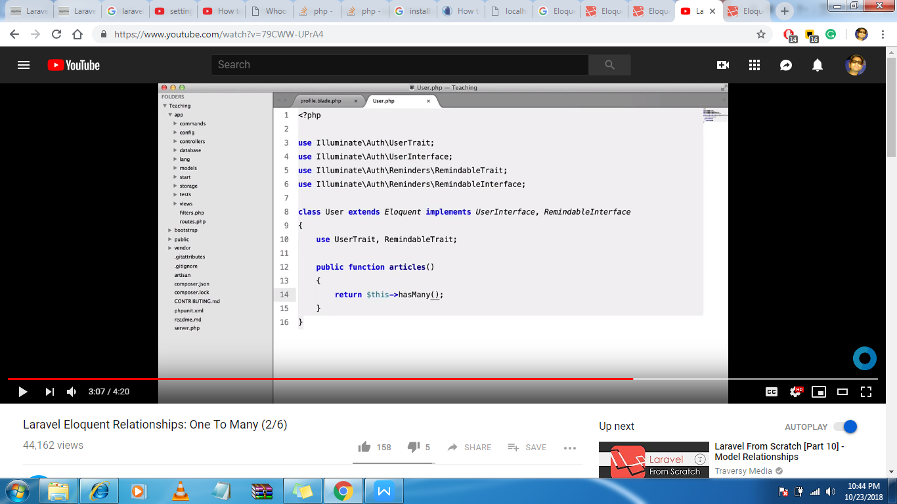

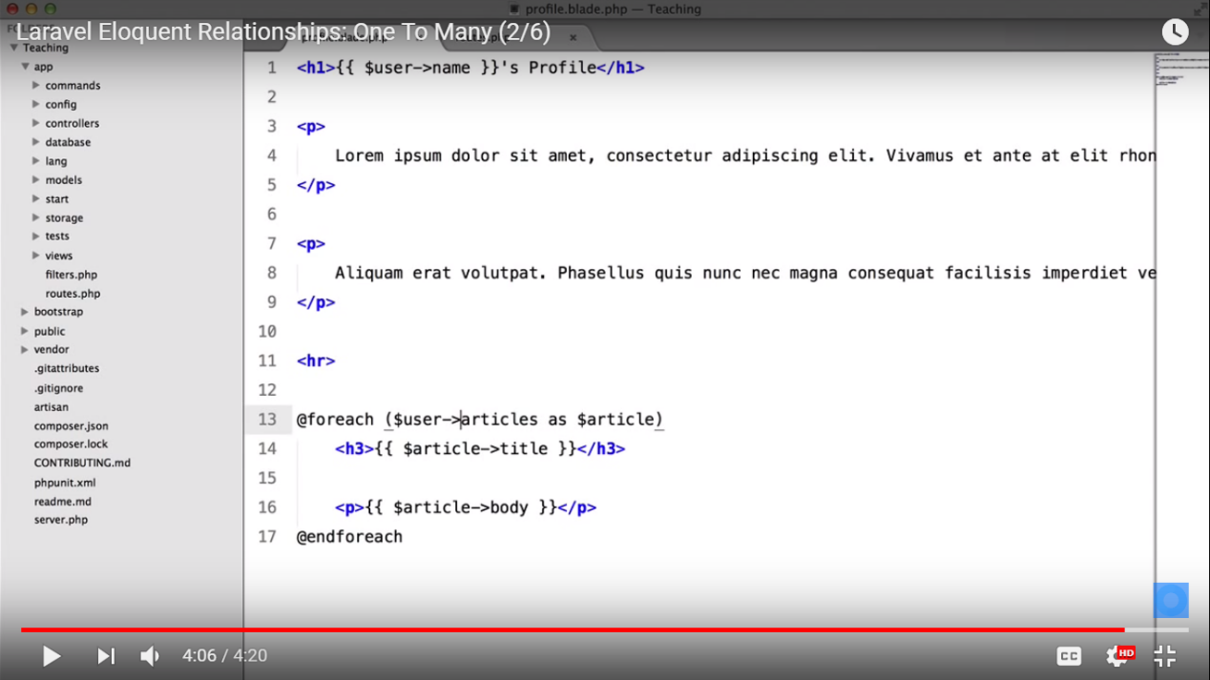

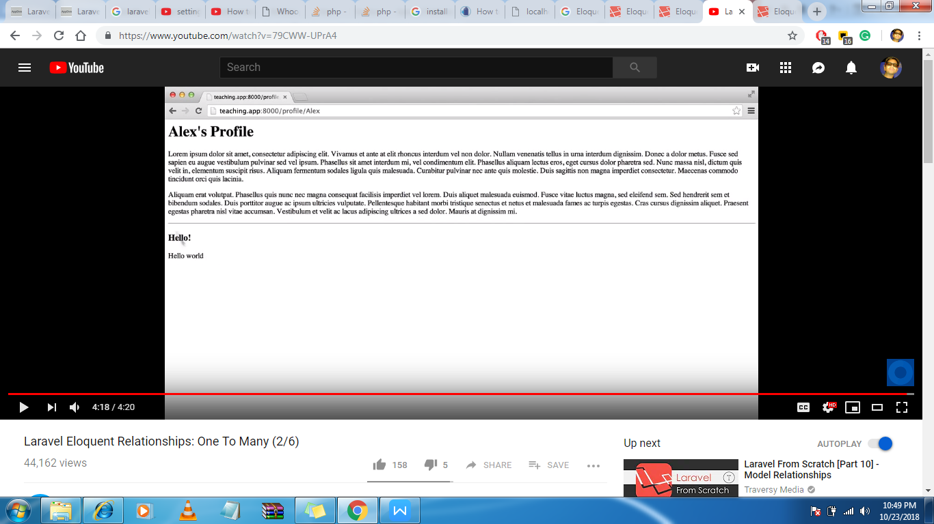

Tuts 3

Model relationship

It means that a post has relationshipwith model and it belongs to user(a single post belongs to user)

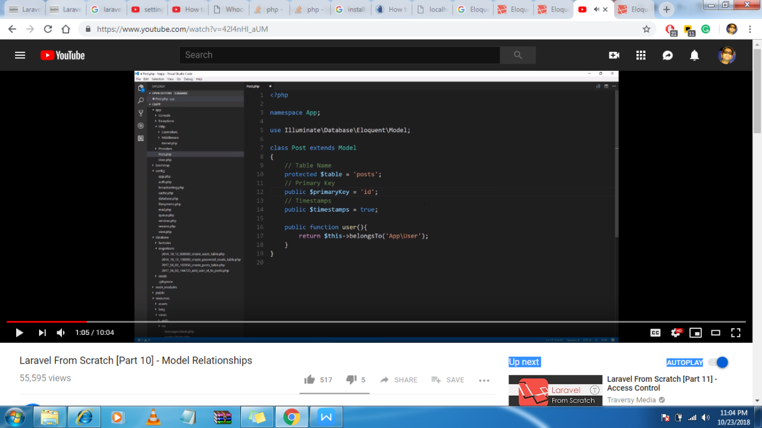

Here a user has many posts

